# Risks for BiteBlend

1. **Any disruptions in the food supply chain can affect menu availability. (N)**
2. **Security breach leading to legal issues. (N)**
3. **The competitor loses market share and the demand for applications increases. (P)**
4. **Technical bugs in the application cause delayed delivery to customers. (N)**
5. **The project might face risks from dependencies on external APIs or data sources, which could change or become unavailable, affecting app functionality. (N)**
6. **Breaches of contracts with restaurants, delivery drivers, or customers can lead to legal disputes. (N)**
7. **Positive user feedback and high ratings could enhance the company’s brand and reputation, leading to new opportunities in other markets or segments. (P)**
8. **Emerging technologies could be leveraged to enhance the app’s features and performance, keeping it ahead of the competition. (P)**
9. Disputes between restaurants and customers. (N)
10. A rapid increase in user registration impacts application performance. (P)
11. An increase in cloud kitchen and restaurant partnerships led to failure in managing logistics. (P)
12. Changes in regulatory laws lead to costly changes to the application. (N)
13. The customer is not satisfied with the recommendations made by the application. (N)

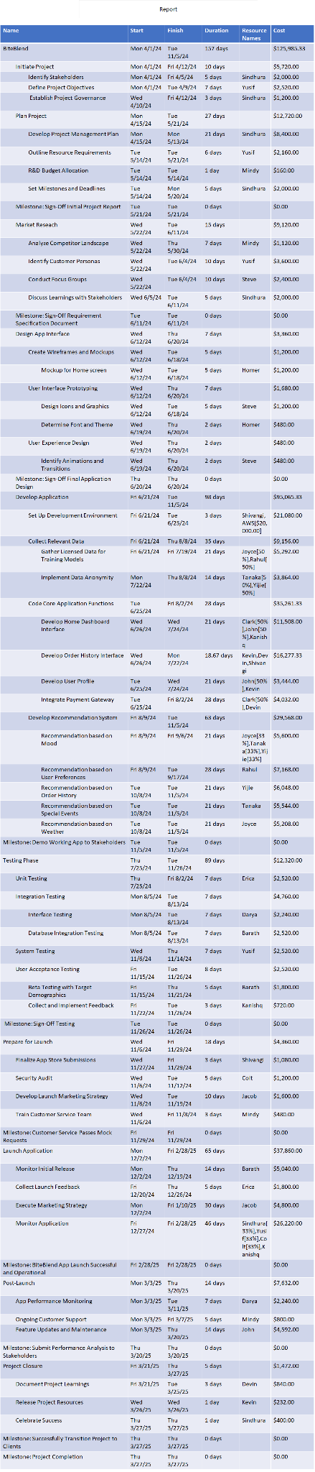



Total Cost Per Resource

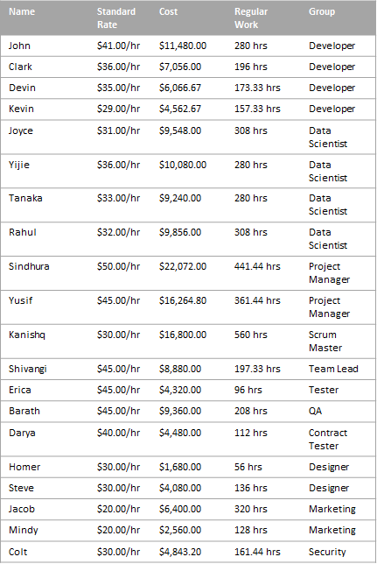

Critical Path

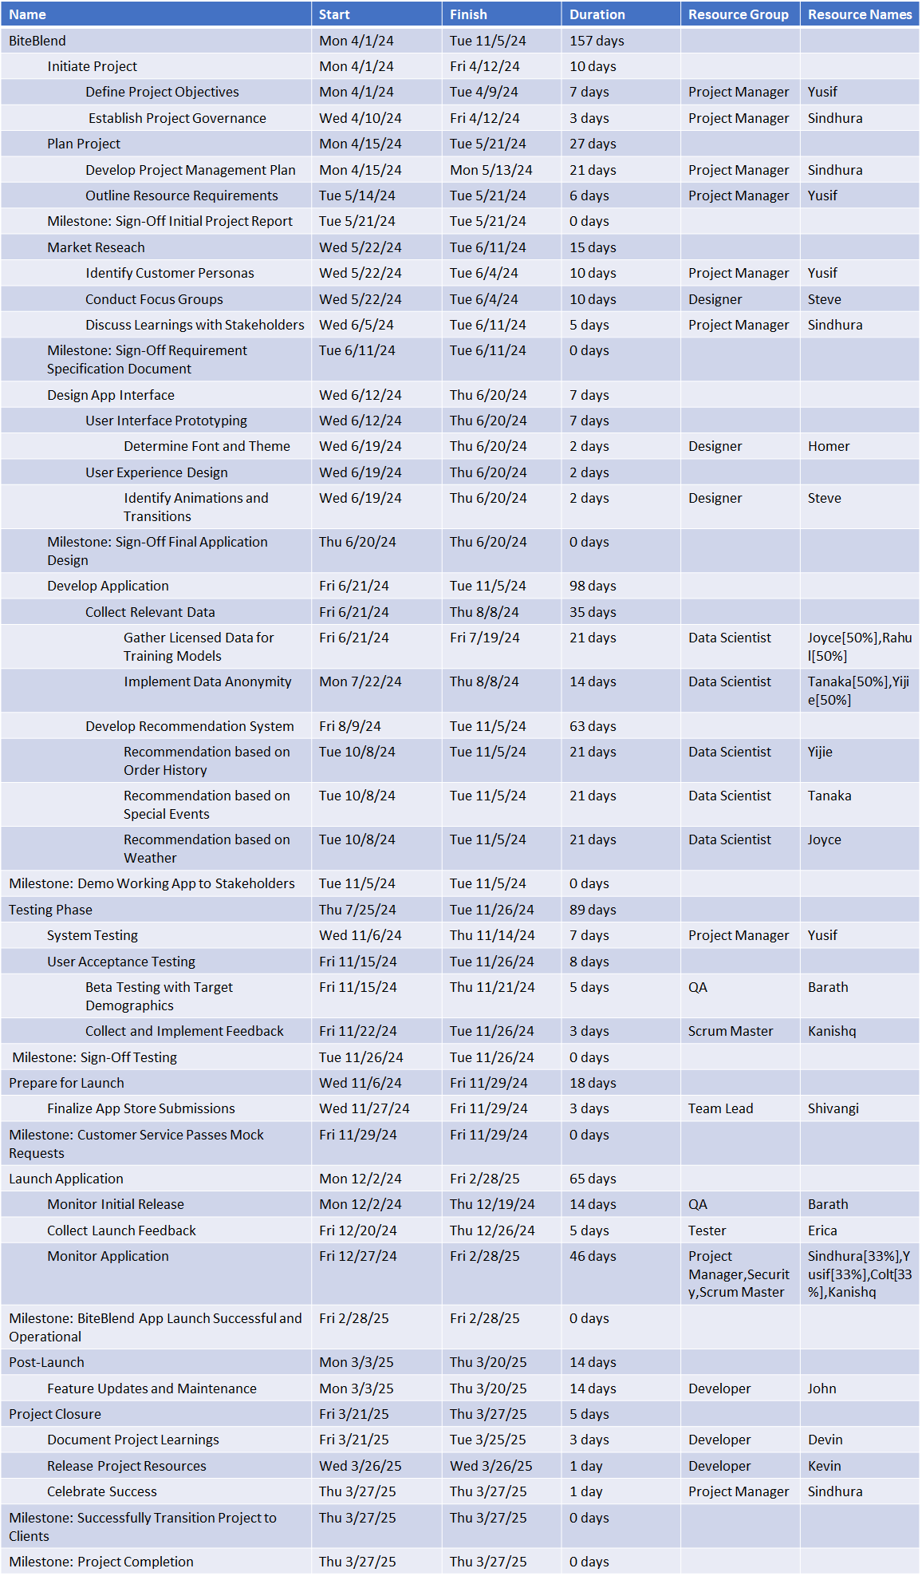



Gantt Chart

